|  |
| --- |
| [Арт 01](http://posmexpert.ru/wp-content/uploads/2014/12/dekorativnye-peregorodki-iz-mdf-01.jpg)**Схема 01** |

[](http://posmexpert.ru/wp-content/uploads/2014/12/dekorativnye-peregorodki-iz-mdf-02.jpg)

|  |
| --- |
| **Схема 02** |

[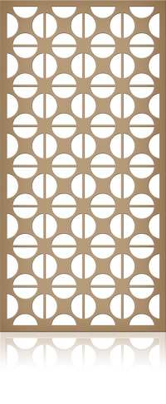](http://posmexpert.ru/wp-content/uploads/2014/12/dekorativnye-peregorodki-iz-mdf-03.jpg)

|  |
| --- |
| **Схема 03** |

[](http://posmexpert.ru/wp-content/uploads/2014/12/dekorativnye-peregorodki-iz-mdf-04.jpg)

|  |
| --- |
| **Схема 04** |

[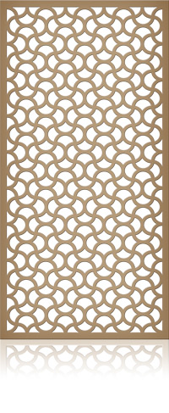](http://posmexpert.ru/wp-content/uploads/2014/12/dekorativnye-peregorodki-iz-mdf-05.jpg)

|  |
| --- |
| **Схема 05** |

[](http://posmexpert.ru/wp-content/uploads/2014/12/dekorativnye-peregorodki-iz-mdf-06.jpg)

|  |
| --- |
| **Схема 06** |

[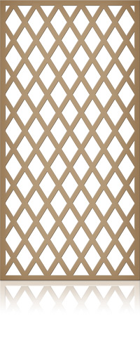](http://posmexpert.ru/wp-content/uploads/2014/12/dekorativnye-peregorodki-iz-mdf-07.jpg)

|  |
| --- |
| **Схема 07** |

[](http://posmexpert.ru/wp-content/uploads/2014/12/dekorativnye-peregorodki-iz-mdf-08.jpg)

|  |
| --- |
| **Схема 08** |

[](http://posmexpert.ru/wp-content/uploads/2014/12/dekorativnye-peregorodki-iz-mdf-09.jpg)

|  |
| --- |
| **Схема 09** |

[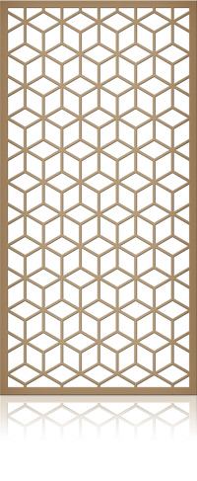](http://posmexpert.ru/wp-content/uploads/2014/12/dekorativnye-peregorodki-iz-mdf-10.jpg)

|  |
| --- |
| **Схема 10** |

[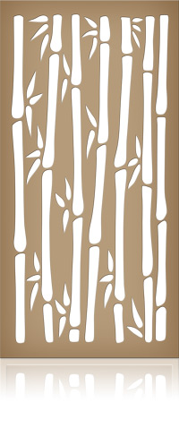](http://posmexpert.ru/wp-content/uploads/2014/12/dekorativnye-peregorodki-iz-mdf-11.jpg)

|  |
| --- |
| **Схема 11** |

[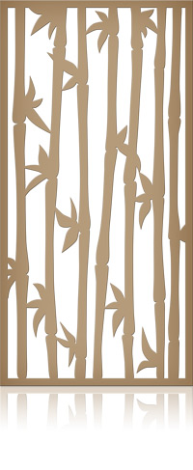](http://posmexpert.ru/wp-content/uploads/2014/12/dekorativnye-peregorodki-iz-mdf-12.jpg)

|  |
| --- |
| **Схема 12** |

[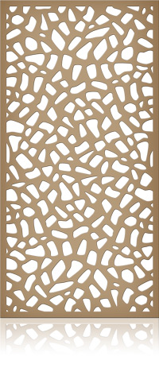](http://posmexpert.ru/wp-content/uploads/2014/12/dekorativnye-peregorodki-iz-mdf-13.jpg)

|  |
| --- |
| **Схема 13** |

[](http://posmexpert.ru/wp-content/uploads/2014/12/dekorativnye-peregorodki-iz-mdf-14.jpg)

|  |
| --- |
| **Схема 14** |

[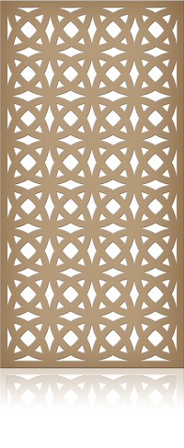](http://posmexpert.ru/wp-content/uploads/2014/12/dekorativnye-peregorodki-iz-mdf-15.jpg)

|  |
| --- |
| **Схема 15** |

[](http://posmexpert.ru/wp-content/uploads/2014/12/dekorativnye-peregorodki-iz-mdf-16.jpg)

|  |
| --- |
| **Схема 16** |

[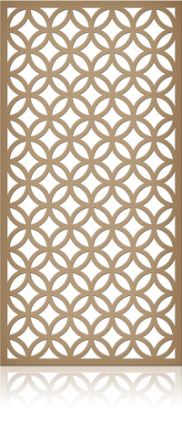](http://posmexpert.ru/wp-content/uploads/2014/12/dekorativnye-peregorodki-iz-mdf-17.jpg)

|  |
| --- |
| **Схема 17** |

[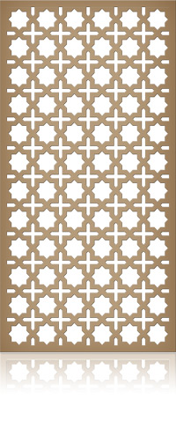](http://posmexpert.ru/wp-content/uploads/2014/12/dekorativnye-peregorodki-iz-mdf-18.jpg)

|  |
| --- |
| **Схема 18** |

[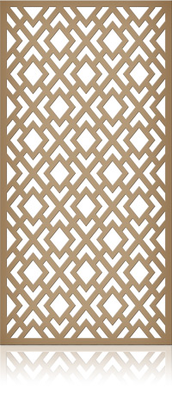](http://posmexpert.ru/wp-content/uploads/2014/12/dekorativnye-peregorodki-iz-mdf-19.jpg)

|  |
| --- |
| **Схема 19** |

[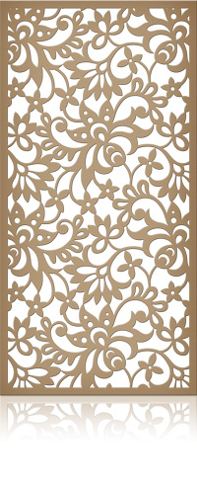](http://posmexpert.ru/wp-content/uploads/2014/12/dekorativnye-peregorodki-iz-mdf-20.jpg)

|  |
| --- |
| **Схема 20** |

[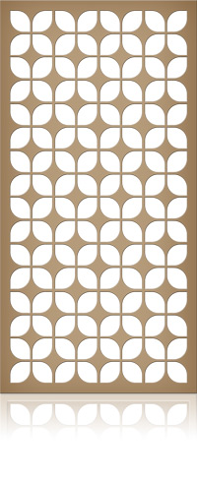](http://posmexpert.ru/wp-content/uploads/2014/12/dekorativnye-peregorodki-iz-mdf-21.jpg)

|  |
| --- |
| **Схема 21** |

[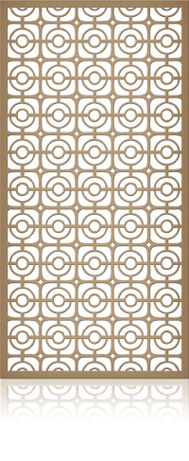](http://posmexpert.ru/wp-content/uploads/2014/12/dekorativnye-peregorodki-iz-mdf-22.jpg)

|  |
| --- |
| **Схема 22** |

[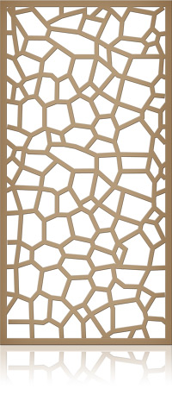](http://posmexpert.ru/wp-content/uploads/2014/12/dekorativnye-peregorodki-iz-mdf-23.jpg)

|  |
| --- |
| **Схема 23** |

[](http://posmexpert.ru/wp-content/uploads/2014/12/dekorativnye-peregorodki-iz-mdf-24.jpg)

|  |
| --- |
| **Схема 24** |

[](http://posmexpert.ru/wp-content/uploads/2014/12/dekorativnye-peregorodki-iz-mdf-25.jpg)

|  |
| --- |
| **Схема 25** |

[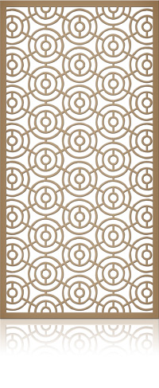](http://posmexpert.ru/wp-content/uploads/2014/12/dekorativnye-peregorodki-iz-mdf-26.jpg)

|  |
| --- |
| **Схема 26** |

[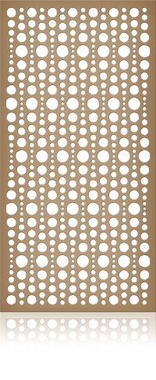](http://posmexpert.ru/wp-content/uploads/2014/12/dekorativnye-peregorodki-iz-mdf-27.jpg)

|  |
| --- |
| **Схема 27** |

[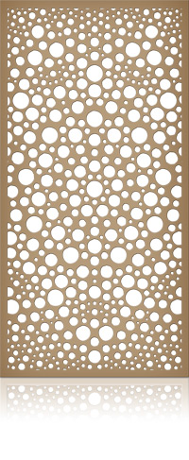](http://posmexpert.ru/wp-content/uploads/2014/12/dekorativnye-peregorodki-iz-mdf-28.jpg)

|  |
| --- |
| **Схема 28** |

[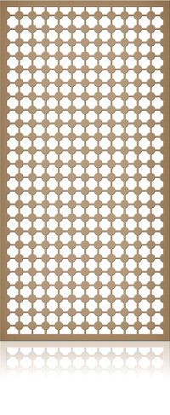](http://posmexpert.ru/wp-content/uploads/2014/12/dekorativnye-peregorodki-iz-mdf-29.jpg)

|  |
| --- |
| **Схема 29** |

[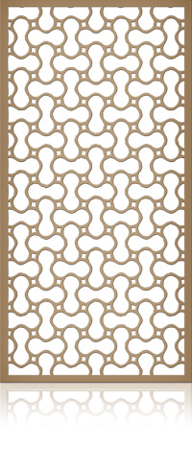](http://posmexpert.ru/wp-content/uploads/2014/12/dekorativnye-peregorodki-iz-mdf-30.jpg)

|  |
| --- |
| **Схема 30** |

[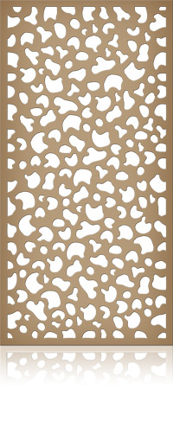](http://posmexpert.ru/wp-content/uploads/2014/12/dekorativnye-peregorodki-iz-mdf-31.jpg)

|  |
| --- |
| **Схема 31** |

[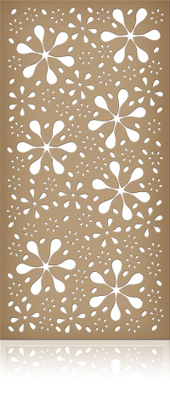](http://posmexpert.ru/wp-content/uploads/2014/12/dekorativnye-peregorodki-iz-mdf-32.jpg)

|  |
| --- |
| **Схема 32** |

[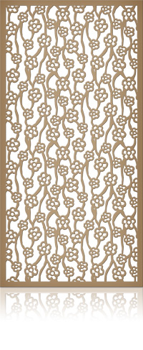](http://posmexpert.ru/wp-content/uploads/2014/12/dekorativnye-peregorodki-iz-mdf-33.jpg)

|  |
| --- |
| **Схема 33** |

[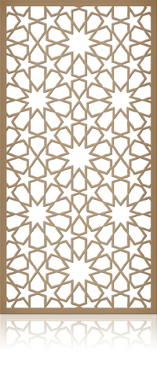](http://posmexpert.ru/wp-content/uploads/2014/12/dekorativnye-peregorodki-iz-mdf-34.jpg)

|  |
| --- |
| **Схема 34** |

[](http://posmexpert.ru/wp-content/uploads/2014/12/dekorativnye-peregorodki-iz-mdf-35.jpg)

|  |
| --- |
| **Схема 35** |

[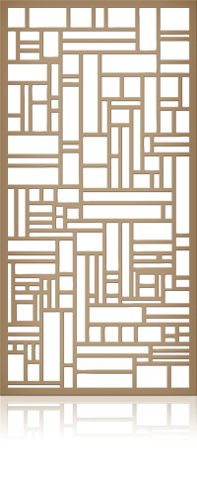](http://posmexpert.ru/wp-content/uploads/2014/12/dekorativnye-peregorodki-iz-mdf-36.jpg)

|  |
| --- |
| **Схема 36** |

[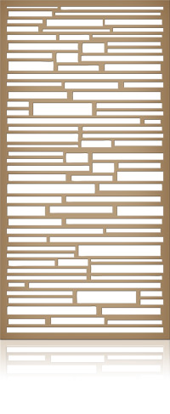](http://posmexpert.ru/wp-content/uploads/2014/12/dekorativnye-peregorodki-iz-mdf-37.jpg)

|  |
| --- |
| **Схема 37** |

[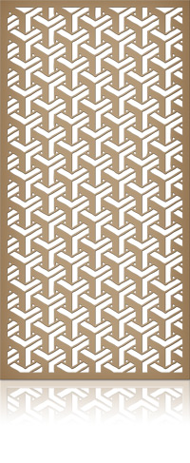](http://posmexpert.ru/wp-content/uploads/2014/12/dekorativnye-peregorodki-iz-mdf-38.jpg)

|  |
| --- |
| **Схема 38** |

[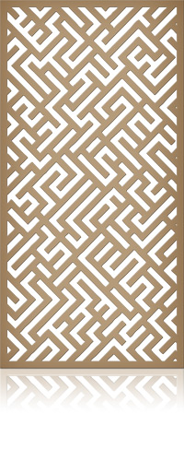](http://posmexpert.ru/wp-content/uploads/2014/12/dekorativnye-peregorodki-iz-mdf-39.jpg)

|  |
| --- |
| **Схема 39** |

[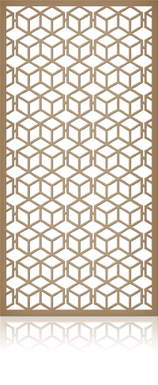](http://posmexpert.ru/wp-content/uploads/2014/12/dekorativnye-peregorodki-iz-mdf-40.jpg)

|  |
| --- |
| **Схема 40** |

[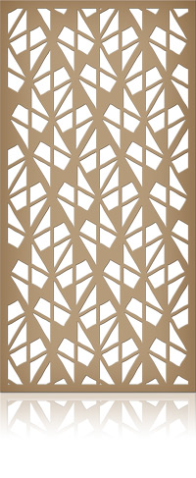](http://posmexpert.ru/wp-content/uploads/2014/12/dekorativnye-peregorodki-iz-mdf-41.jpg)

|  |
| --- |
| **Схема 41** |

[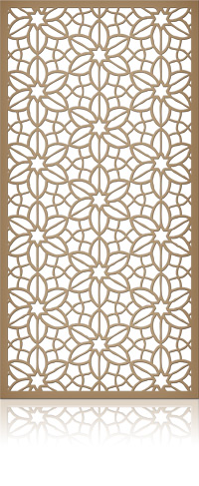](http://posmexpert.ru/wp-content/uploads/2014/12/dekorativnye-peregorodki-iz-mdf-42.jpg)

|  |
| --- |
| **Схема 42** |

[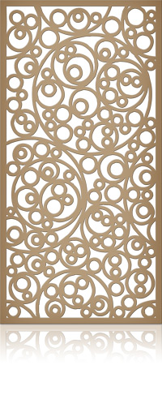](http://posmexpert.ru/wp-content/uploads/2014/12/dekorativnye-peregorodki-iz-mdf-43.jpg)

|  |
| --- |
| **Схема 43** |

[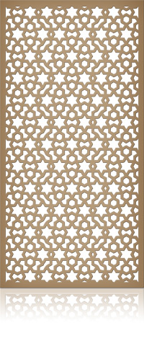](http://posmexpert.ru/wp-content/uploads/2014/12/dekorativnye-peregorodki-iz-mdf-44.jpg)

|  |
| --- |
| **Схема 44** |

[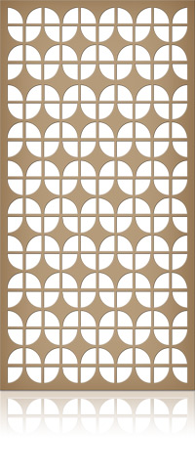](http://posmexpert.ru/wp-content/uploads/2014/12/dekorativnye-peregorodki-iz-mdf-45.jpg)

|  |  |  |
| --- | --- | --- |
| **Схема 45** | | |
|  |  |  |
|  |  |  |
|  |  |  |
|  |  |  |

[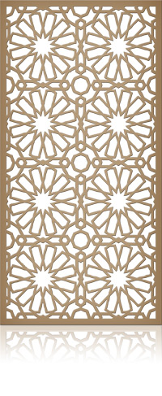](http://posmexpert.ru/wp-content/uploads/2014/12/dekorativnye-peregorodki-iz-mdf-46.jpg)

|  |  |  |
| --- | --- | --- |
| **Схема 46** | | |
|  |  |  |
|  |  |  |
|  |  |  |
|  |  |  |

[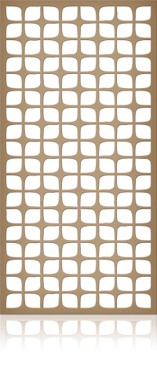](http://posmexpert.ru/wp-content/uploads/2014/12/dekorativnye-peregorodki-iz-mdf-47.jpg)

|  |  |  |
| --- | --- | --- |
| **Схема 47** | | |
|  |  |  |
|  |  |  |
|  |  |  |
|  |  |  |

[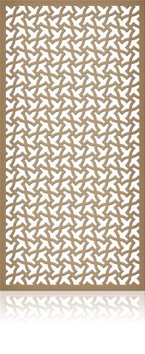](http://posmexpert.ru/wp-content/uploads/2014/12/dekorativnye-peregorodki-iz-mdf-48.jpg)

|  |  |  |
| --- | --- | --- |
| **Схема 48** | | |
|  |  |  |
|  |  |  |
|  |  |  |
|  |  |  |

[](http://posmexpert.ru/wp-content/uploads/2014/12/dekorativnye-peregorodki-iz-mdf-49.jpg)

|  |  |  |
| --- | --- | --- |
| **Схема 49** | | |
|  |  |  |
|  |  |  |
|  |  |  |
|  |  |  |

[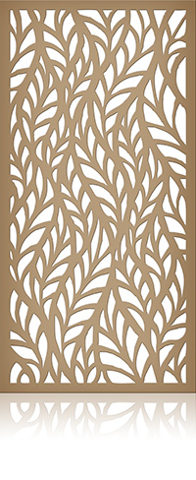](http://posmexpert.ru/wp-content/uploads/2014/12/dekorativnye-peregorodki-iz-mdf-50.jpg)

|  |  |  |
| --- | --- | --- |
| **Схема 50** | | |
|  |  |  |
|  |  |  |
|  |  |  |
|  |  |  |

[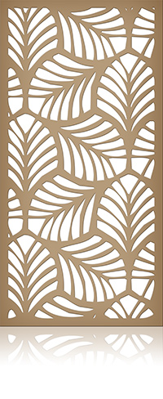](http://posmexpert.ru/wp-content/uploads/2014/12/dekorativnye-peregorodki-iz-mdf-51.jpg)

|  |  |  |
| --- | --- | --- |
| **Схема 51** | | |
|  |  |  |
|  |  |  |
|  |  |  |
|  |  |  |

[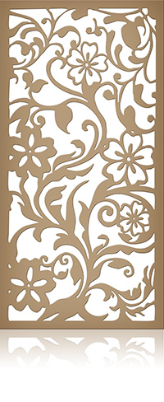](http://posmexpert.ru/wp-content/uploads/2014/12/dekorativnye-peregorodki-iz-mdf-52.jpg)

|  |  |  |
| --- | --- | --- |
| **Схема 52** | | |
|  |  |  |
|  |  |  |
|  |  |  |
|  |  |  |

[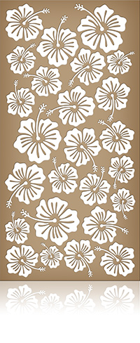](http://posmexpert.ru/wp-content/uploads/2014/12/dekorativnye-peregorodki-iz-mdf-53.jpg)

|  |  |  |
| --- | --- | --- |
| **Схема 53** | | |
|  |  |  |
|  |  |  |
|  |  |  |
|  |  |  |

[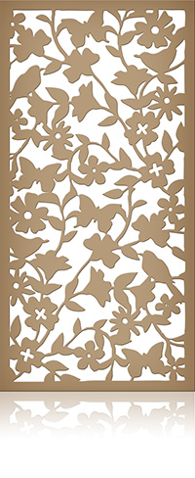](http://posmexpert.ru/wp-content/uploads/2014/12/dekorativnye-peregorodki-iz-mdf-54.jpg)

|  |  |  |
| --- | --- | --- |
| **Схема 54** | | |
|  |  |  |
|  |  |  |
|  |  |  |
|  |  |  |

[](http://posmexpert.ru/wp-content/uploads/2014/12/dekorativnye-peregorodki-iz-mdf-55.jpg)

|  |  |  |
| --- | --- | --- |
| **Схема 55** | | |
|  |  |  |
|  |  |  |
|  |  |  |
|  |  |  |

[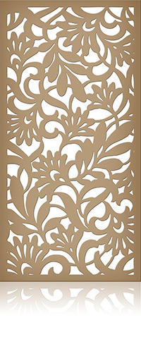](http://posmexpert.ru/wp-content/uploads/2016/12/dekorativnye-peregorodki-iz-mdf-56.jpg)

|  |  |  |
| --- | --- | --- |
| **Схема 56** | | |
|  |  |  |
|  |  |  |
|  |  |  |
|  |  |  |

[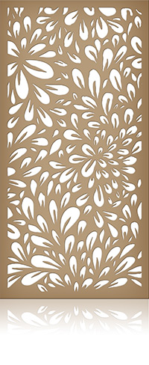](http://posmexpert.ru/wp-content/uploads/2016/12/dekorativnye-peregorodki-iz-mdf-57.jpg)

|  |  |  |
| --- | --- | --- |
| **Схема 57** | | |
|  |  |  |
|  |  |  |
|  |  |  |
|  |  |  |

[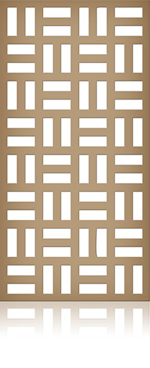](http://posmexpert.ru/wp-content/uploads/2016/12/dekorativnye-peregorodki-iz-mdf-58.jpg)

|  |  |  |
| --- | --- | --- |
| **Схема 58** | | |
|  |  |  |
|  |  |  |
|  |  |  |
|  |  |  |

[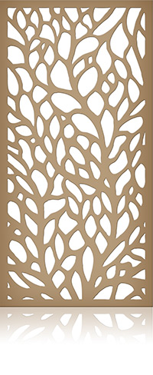](http://posmexpert.ru/wp-content/uploads/2016/12/dekorativnye-peregorodki-iz-mdf-59.jpg)

|  |  |  |
| --- | --- | --- |
| **Схема 59** | | |
|  |  |  |
|  |  |  |
|  |  |  |
|  |  |  |

[](http://posmexpert.ru/wp-content/uploads/2016/12/dekorativnye-peregorodki-iz-mdf-60.jpg)

|  |  |  |
| --- | --- | --- |
| **Схема 60** | | |
|  |  |  |
|  |  |  |
|  |  |  |
|  |  |  |

[](http://posmexpert.ru/wp-content/uploads/2018/05/dekorativnye-peregorodki-iz-mdf-61.jpg)

|  |  |  |
| --- | --- | --- |
| **Схема 61** | | |
|  |  |  |
|  |  |  |
|  |  |  |
|  |  |  |

[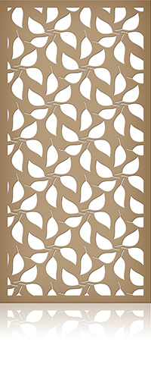](http://posmexpert.ru/wp-content/uploads/2018/05/dekorativnye-peregorodki-iz-mdf-62.jpg)

|  |  |  |
| --- | --- | --- |
| **Схема 62** | | |
|  |  |  |
|  |  |  |
|  |  |  |
|  |  |  |

[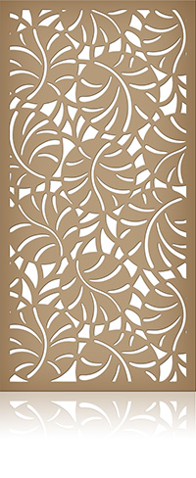](http://posmexpert.ru/wp-content/uploads/2018/05/dekorativnye-peregorodki-iz-mdf-63.jpg)

|  |  |  |
| --- | --- | --- |
| **Схема 63** | | |
|  |  |  |
|  |  |  |
|  |  |  |
|  |  |  |

[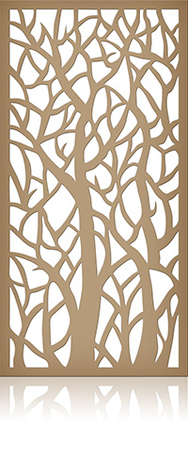](http://posmexpert.ru/wp-content/uploads/2018/05/dekorativnye-peregorodki-iz-mdf-64.jpg)

|  |  |  |
| --- | --- | --- |
| **Схема 64** | | |
|  |  |  |
|  |  |  |
|  |  |  |
|  |  |  |

[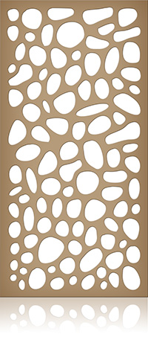](http://posmexpert.ru/wp-content/uploads/2018/05/dekorativnye-peregorodki-iz-mdf-65.jpg)

|  |  |  |
| --- | --- | --- |
| **Схема 65** | | |
|  |  |  |
|  |  |  |
|  |  |  |
|  |  |  |